Task 001:

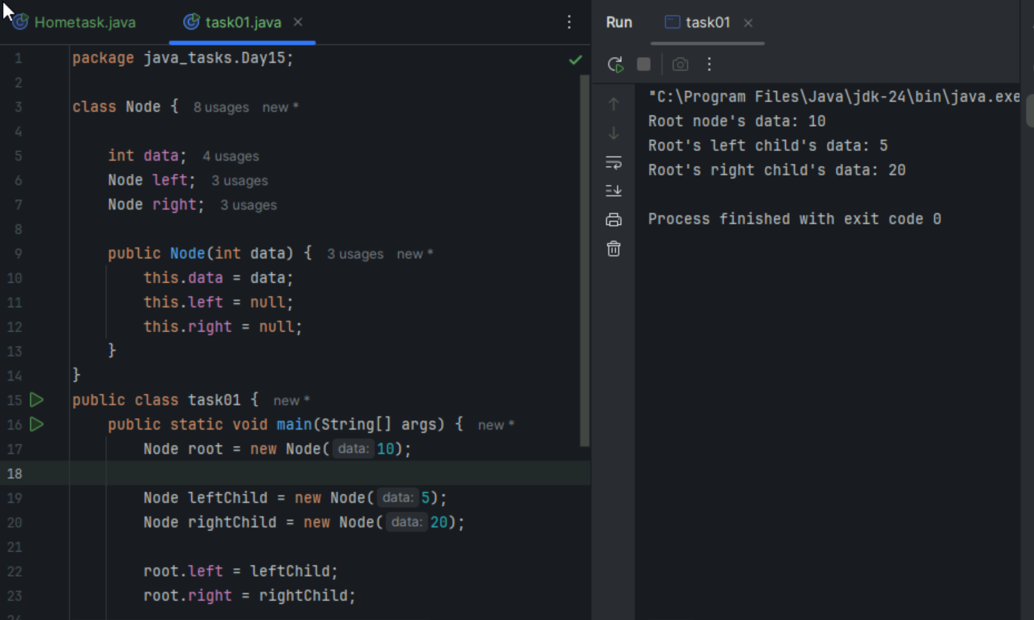

Task2:
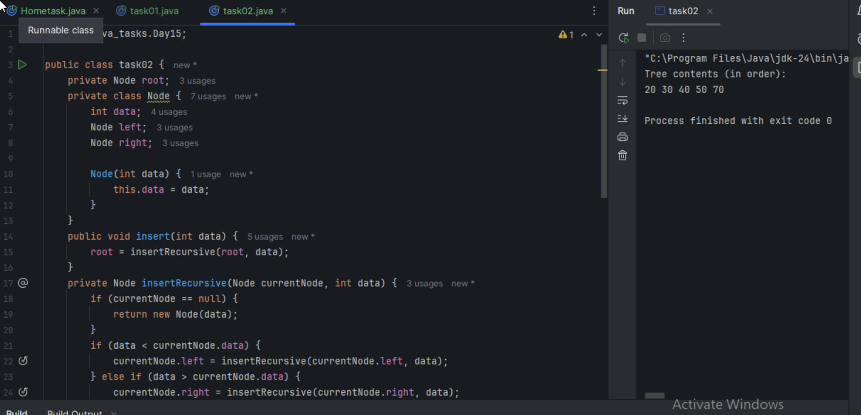

Task 03 a:
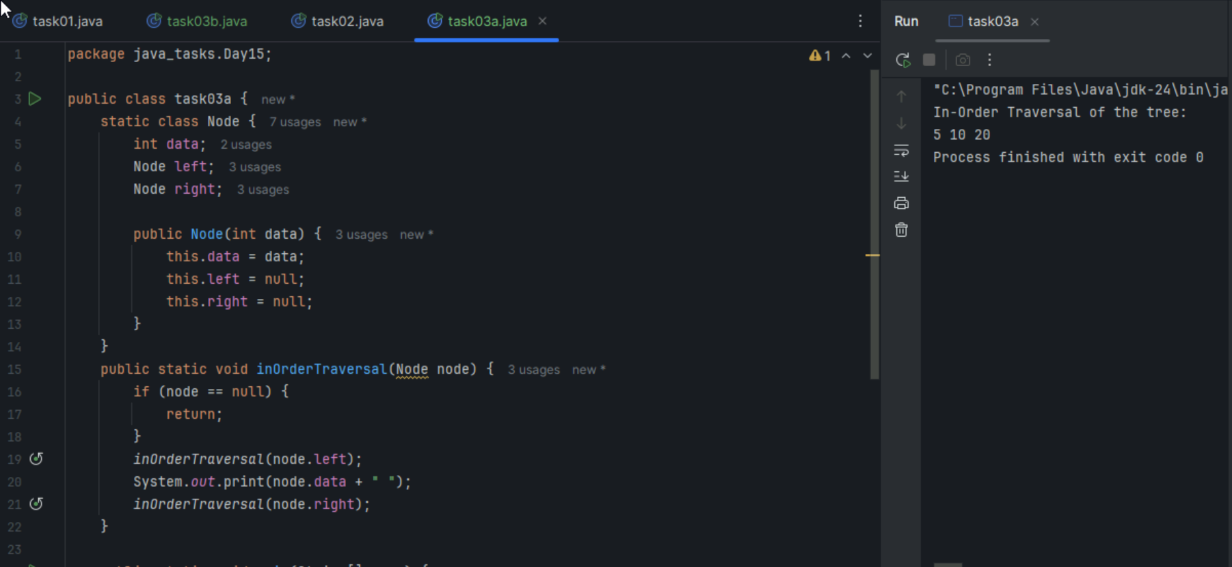
Task 03b:
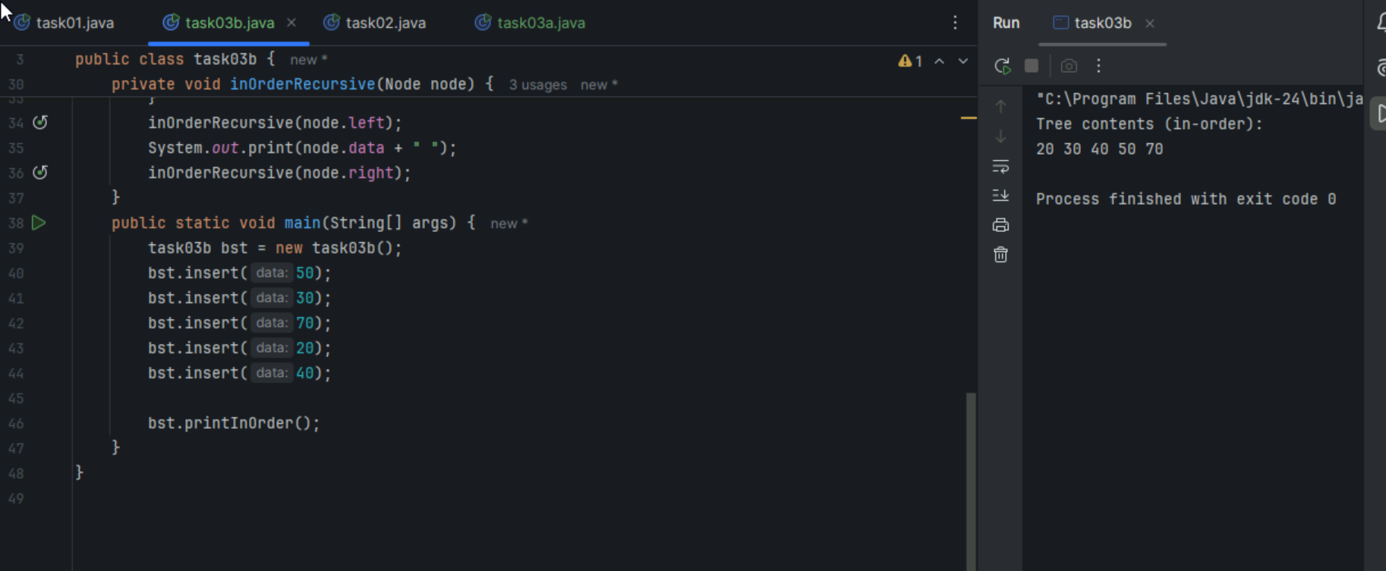

Task 04:
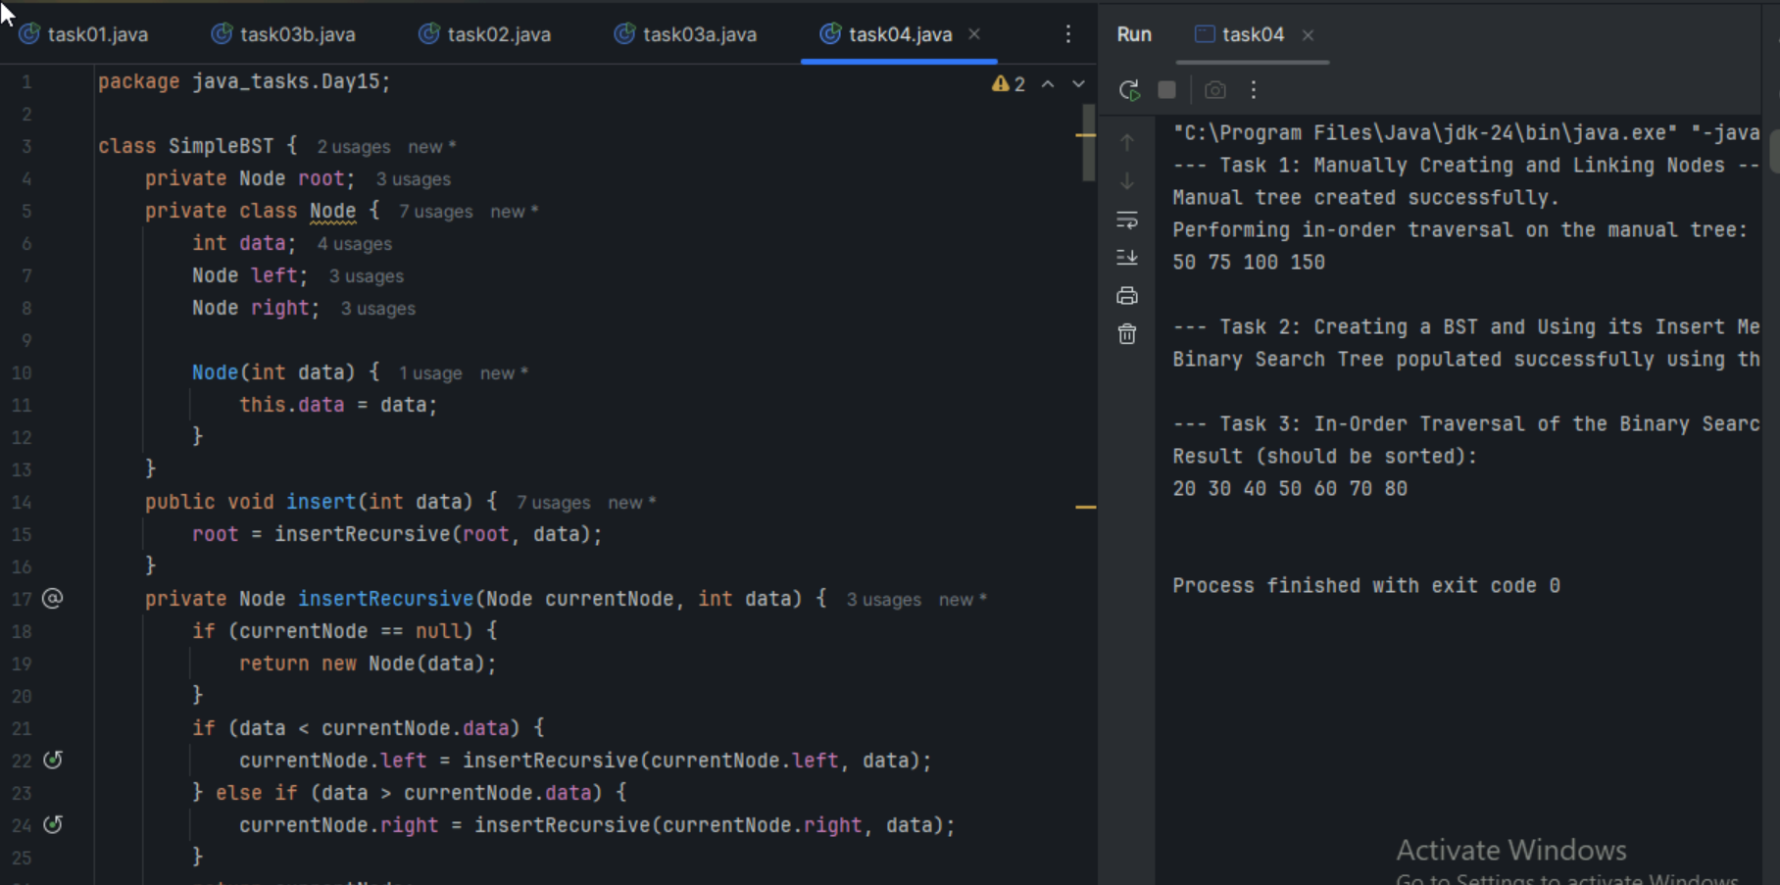

Task5:
Applications of trees:
Hierarchal data representation
Binary search
Syntax trees
Network routing algorithms and spanning trees
Decision making trees
Task6:
class TreeNode {
int item;
TreeNode left, right;

TreeNode(int item) {
this.item = item;
left = right = null;
}
}

class BinarySearchTreeOp02 {
TreeNode root;

public BinarySearchTreeOp02() {
this.root = null;
}

public void insert(int item) {
root = insertRec(root, item);
}

private TreeNode insertRec(TreeNode root, int item) {
if (root == null) {
root = new TreeNode(item);
return root;
}

if (item < root.item) {
root.left = insertRec(root.left, item);
} else if (item > root.item) {
root.right = insertRec(root.right, item);
}

return root;
}

public TreeNode search(int key) {
TreeNode current = root;
while (current != null) {
if (key == current.item) {
return current;
} else if (key < current.item) {
current = current.left;
} else {
current = current.right;
}
}
return null;
}

public void inorder() {
inorderRec(root);
System.out.println();
}

private void inorderRec(TreeNode root) {
if (root != null) {
inorderRec(root.left);
System.out.print(root.item + " ");
inorderRec(root.right);
}
}

public static void main(String[] args) {
BinarySearchTreeOp02 bst = new BinarySearchTreeOp02();

System.out.println("Inserting elements: 50, 30, 70, 20, 40, 60, 80");
bst.insert(50);
bst.insert(30);
bst.insert(70);
bst.insert(20);
bst.insert(40);
bst.insert(60);
bst.insert(80);

System.out.print("In-order traversal: ");
bst.inorder();

System.out.println("\nSearching for elements:");
int searchKey1 = 40;
TreeNode result1 = bst.search(searchKey1);
if (result1 != null) {
System.out.println("Found " + searchKey1 + " in the tree.");
} else {
System.out.println(searchKey1 + " not found in the tree.");
}

int searchKey2 = 99;
TreeNode result2 = bst.search(searchKey2);
if (result2 != null) {
System.out.println("Found " + searchKey2 + " in the tree.");
} else {
System.out.println(searchKey2 + " not found in the tree.");
}
}
}
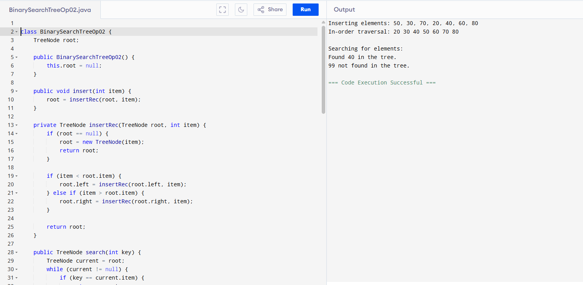

Task7:
Full Binary tree
Complete Binary tree
Perfect Binary tree
Skewed Binary tree
Balanced Binary tree
Task8:
Social Networks
Mapping Navigation
Computer Networks
World Wide Web
Logistics and Supply chain
Scheduling
Resource allocation
Biology and genetics
Chemical structures
Task9:
Undirected graph
Directed graph
Weighted graph
Unweighted graphs
Cyclic Graph
Acyclic graph
Task10:
class Graph01 {
class Edge {
int src, dest;
}
int vertices, edges;

Edge[] edge;

Graph01(int vertices, int edges) {
this.vertices = vertices;
this.edges = edges;

edge = new Edge[edges];
for(int i = 0; i < edges; i++) {
edge[i] = new Edge();
}
}

public static void main(String[] args) {
int noVertices = 5;
int noEdges = 8;
Graph01 gObj = new Graph01(noVertices, noEdges);

gObj.edge[0].src = 1;
gObj.edge[0].dest = 2;
gObj.edge[1].src = 1;
gObj.edge[1].dest = 3;
gObj.edge[2].src = 1;
gObj.edge[2].dest = 4;
gObj.edge[3].src = 2;
gObj.edge[3].dest = 4;
gObj.edge[4].src = 2;
gObj.edge[4].dest = 5;
gObj.edge[5].src = 3;
gObj.edge[5].dest = 4;
gObj.edge[6].src = 3;
gObj.edge[6].dest = 5;
gObj.edge[7].src = 4;
gObj.edge[7].dest = 5;

for(int i =0; i < noEdges; i++) {
System.out.println(gObj.edge[i].src+ " - " + gObj.edge[i].dest);
}
}
}
